**Assignment 02 – MySQL Basics Part 2**

**1. Fetch all the Customer Details along with the product names that the customer has ordered.**

SELECT c.Customer_Id, c.Customer_Name, p.Product_Name

FROM customer c

INNER JOIN `order` o

ON c.Customer_Id = o.Customer_Id

INNER JOIN order_details od

ON o.Order_Id = od.Order_Id

INNER JOIN product p

ON od.Product_Id = p.Product_Id;

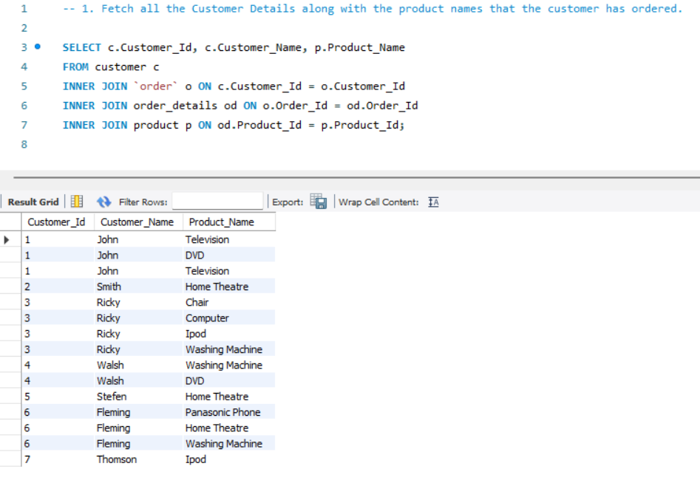

**2. Fetch Order_Id, Ordered_Date, Total Price of the order (product price * qty)**

SELECT o.Order_Id, o.Ordered_Date,

SUM(p.Product_Price * od.Quantity) AS Total_Price

FROM `order` o

INNER JOIN order_details od

ON o.Order_Id = od.Order_Id

INNER JOIN product p

ON od.Product_Id = p.Product_Id

GROUP BY

o.Order_Id, o.Ordered_Date;

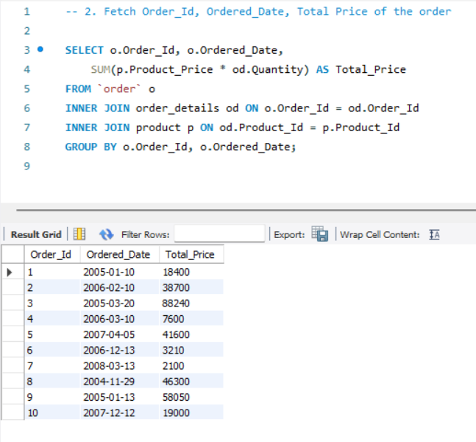

**3. Fetch the Customer Name, who has not placed any order**

SELECT c.Customer_Name

FROM customer c

LEFT JOIN `order` o

ON c.Customer_Id = o.Customer_Id

WHERE

o.Customer_Id IS NULL;

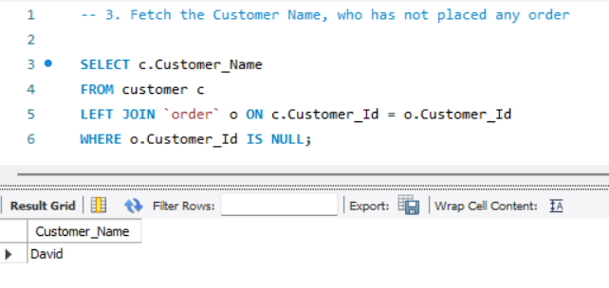

**4. Fetch the Product Details without any order(purchase)**

SELECT p.*

FROM product p

LEFT JOIN order_details od

ON p.Product_Id = od.Product_Id

WHERE

p.Product_Id IS NULL;

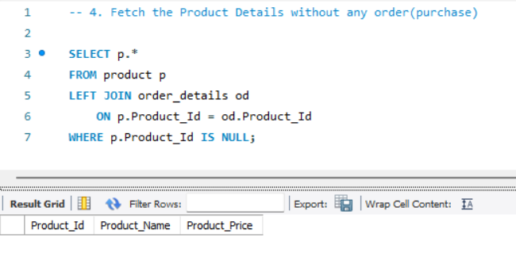

**5. Fetch the Customer name along with the total Purchase Amount**

SELECT c.Customer_Name,

SUM(p.Product_Price * od.Quantity) AS Total_Purshase_Amount

FROM customer c

INNER JOIN `order` o

ON c.Customer_Id = o.Customer_Id

INNER JOIN order_details od

ON o.Order_Id = od.Order_Id

INNER JOIN product p

ON od.Product_Id = p.Product_Id

GROUP BY c.Customer_Id, c.Customer_Name;

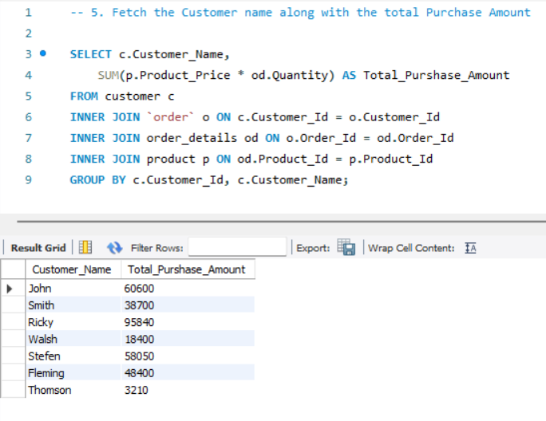

**6. Fetch the Customer details, who has placed the first and last order**

SELECT c.*, o.Ordered_Date AS First_and_Last_Order

FROM customer c

JOIN `order` o

ON c.Customer_Id = o.Customer_Id

WHERE o.Ordered_Date IN (

(SELECT MIN(Ordered_Date) FROM `order`),

(SELECT MAX(Ordered_Date) FROM `order`)

);

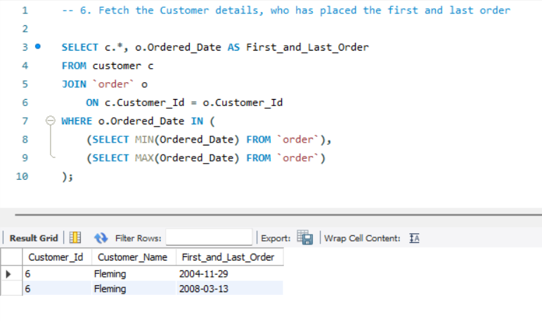

**7. Fetch the customer details, who has placed a greater number of orders**

SELECT c.*,

COUNT(o.Order_Id) AS Total_Orders

FROM customer c

LEFT JOIN `order` o

ON c.Customer_Id = o.Customer_Id

GROUP BY

c.Customer_Id, c.Customer_Name

ORDER BY

Total_Orders DESC

LIMIT 1;

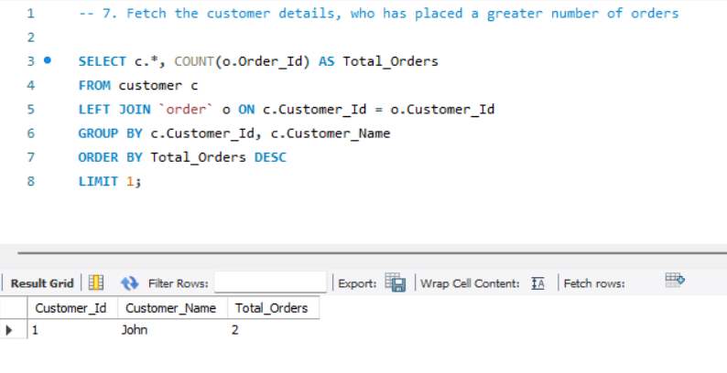

**8. Fetch the customer details, who has placed multiple orders in the same year**

SELECT c.*,

YEAR(o.Ordered_Date) AS Order_Year,

COUNT(o.Order_Id) AS Total_Orders

FROM customer c

LEFT JOIN `order` o

ON c.Customer_Id = o.Customer_Id

GROUP BY

c.Customer_Id, c.Customer_Name,

YEAR(o.Ordered_Date)

HAVING

COUNT(o.Order_Id) > 1;

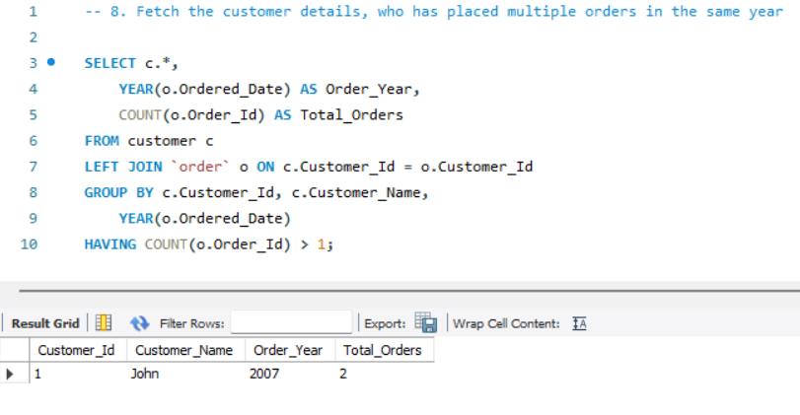

**9. Fetch the name of the month, in which a greater number of orders has been placed**

SELECT

MONTHNAME(o.Ordered_Date) AS Month_Name,

COUNT(o.Order_Id) AS Total_Orders

FROM `Order` o

GROUP BY

MONTH(o.Ordered_Date)

ORDER BY

Total_Orders DESC

LIMIT 1;

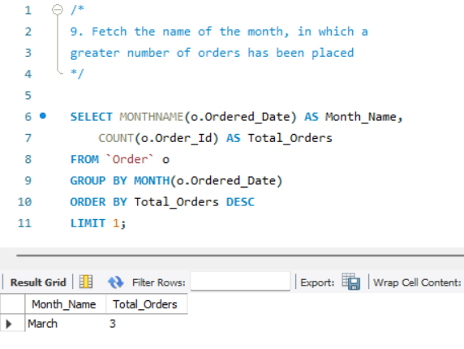

**10. Fetch the maximum priced Ordered Product**

SELECT p.*

FROM product p

INNER JOIN order_details od

ON p.Product_Id = od.Product_Id

ORDER BY

p.Product_Price DESC

LIMIT 1;

